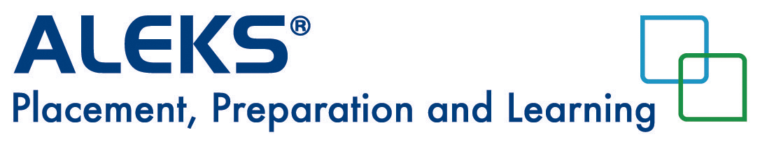
Students Re-subscription and Access Code Purchase

To purchase a new subscription, follow the instructions below:

- Once the Learning Module is expired, select Account Home in the upper right hand corner.

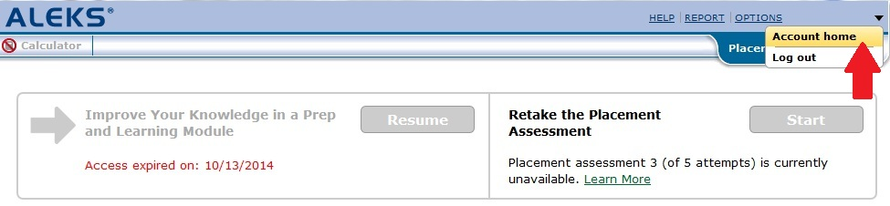

- From your Student Account Home, click on the Sign up for a new class button.
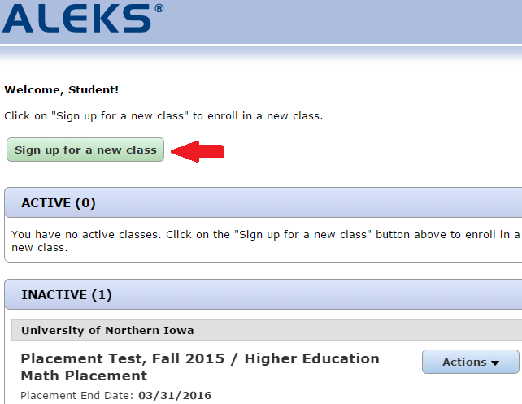

- Enter the 10-character course code for your placement cohort. Click on the >>Register button.
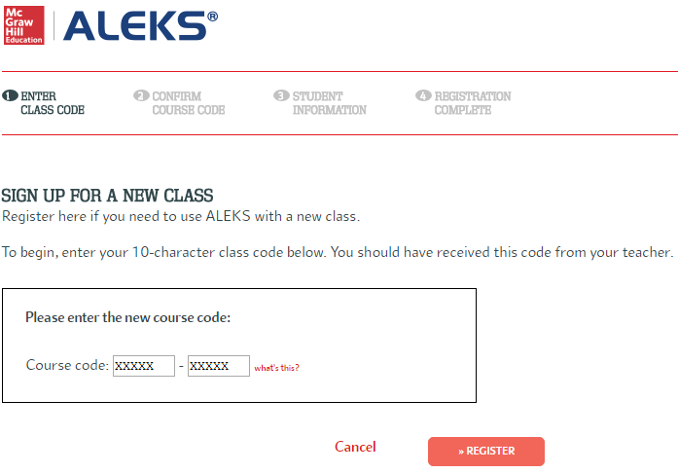

- Verify the placement cohort information. Click on the >> Continue button.
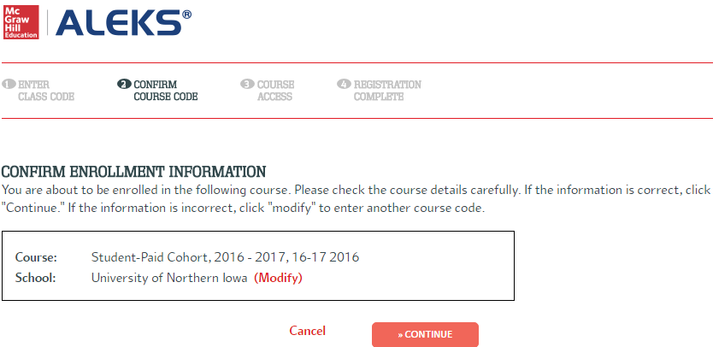

- Click on the >> Purchase access online link.
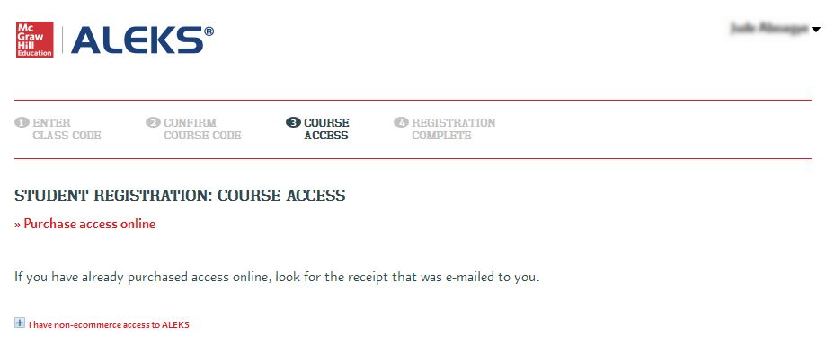

- Complete your payment information. Click on the Review Order button.
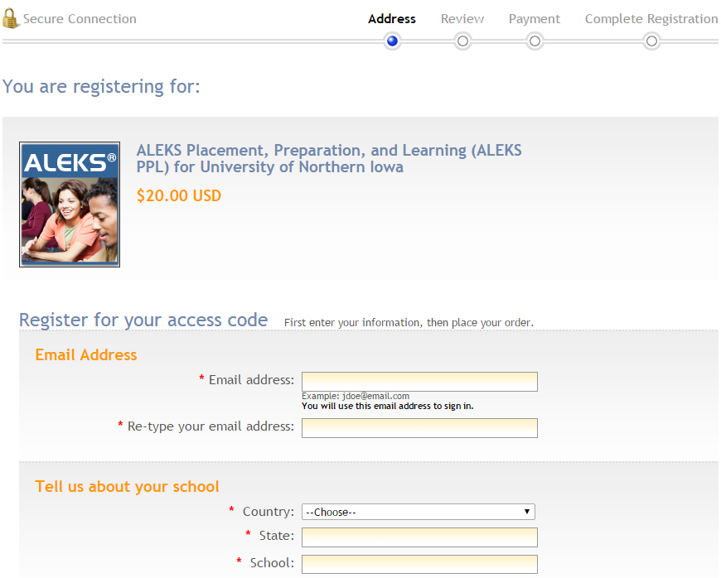
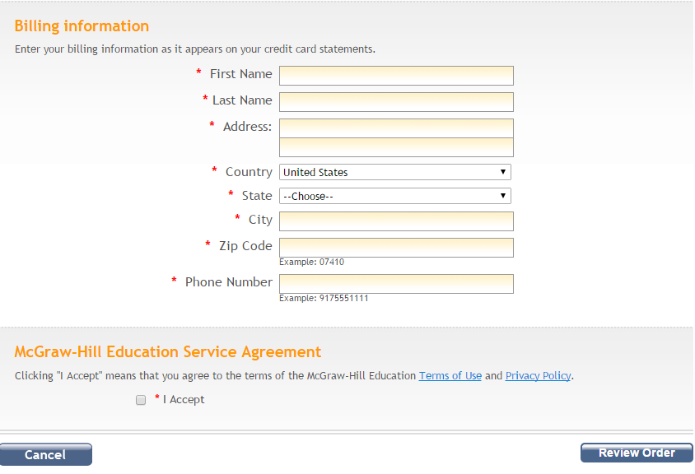

- Review your order. Click on the Payment button.
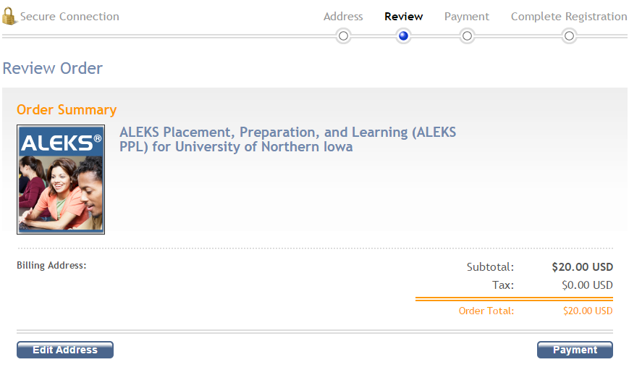

- Click on the Place Order button to complete your purchase.
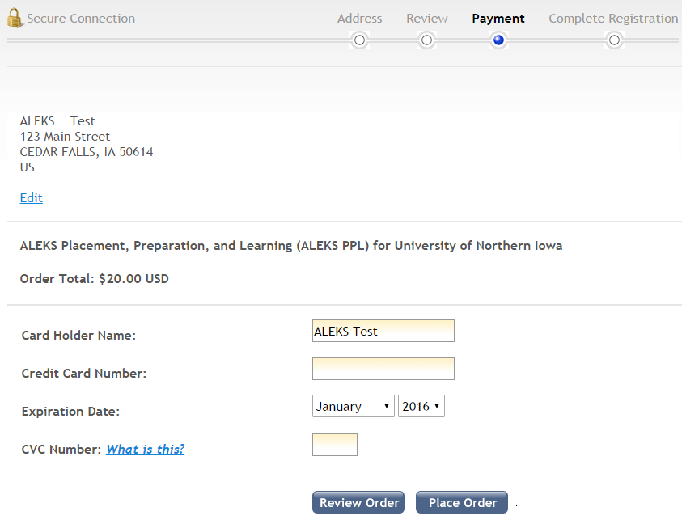

- Click on the >> Continue Sign Up button to register your access code.
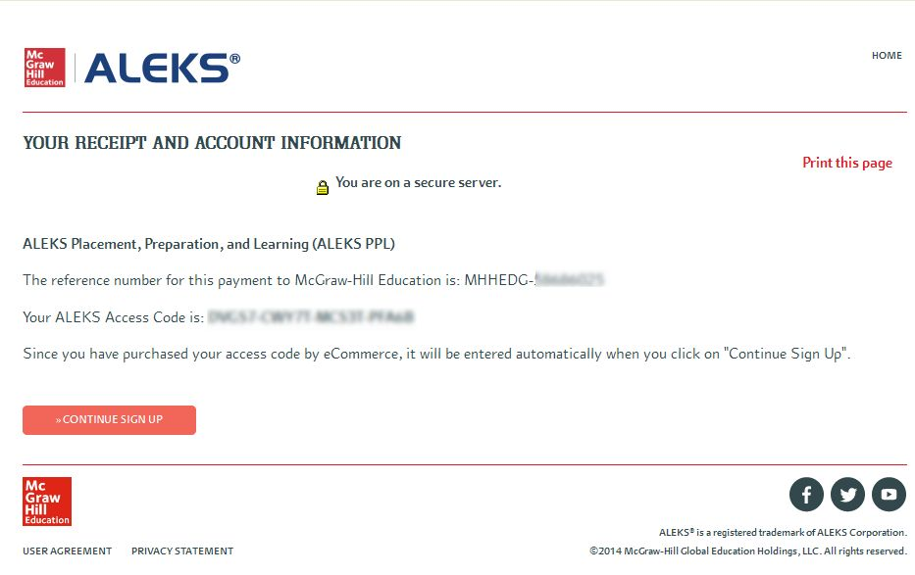

- Fill in your student information. Click on the >>Continue to your ALEKS class button.
