If your access has expired, you can use these instructions to purchase additional access.

Purchasing a New Subscription
- From your Student Account Home, click Add Class.

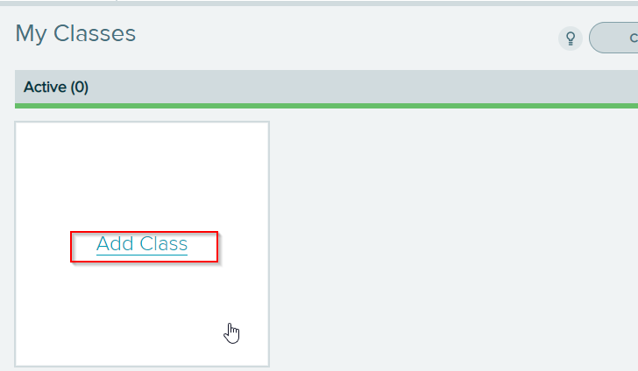

- Enter the 10-character course code for your placement cohort. Click Continue.
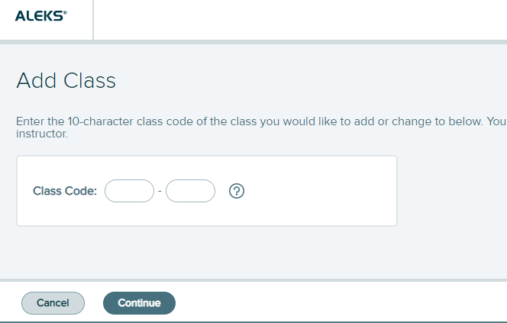

- Verify the placement cohort information. Click Confirm.
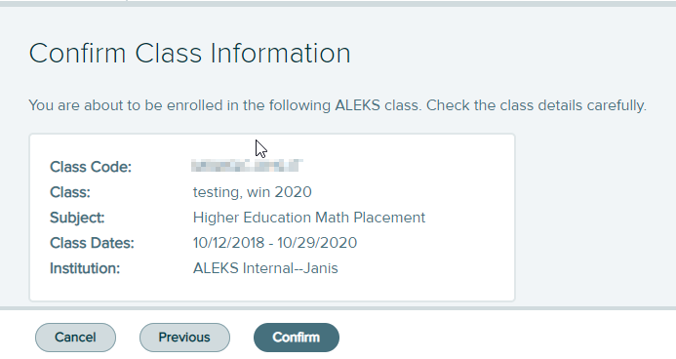

- Click on No, I need to purchase an access code. Click Continue.
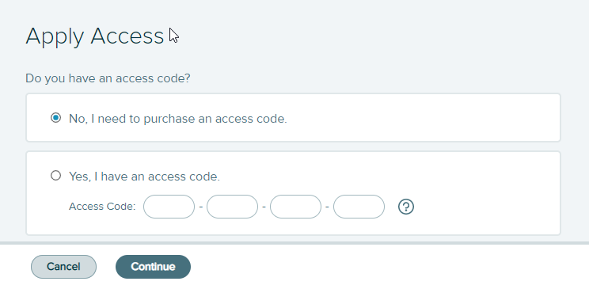

- Enter your information. Click Review Order.

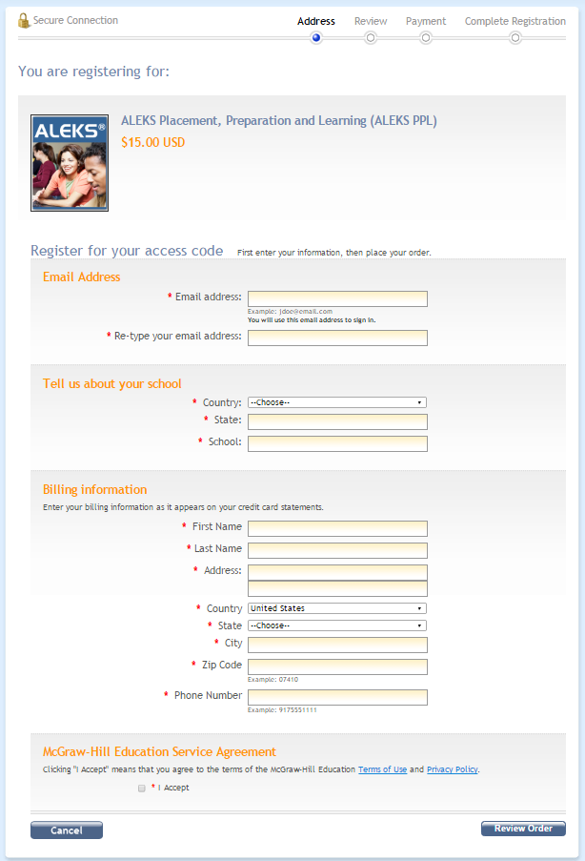

- Confirm your order details are correct. Click Payment.
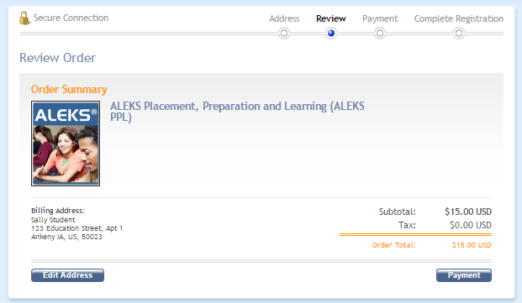

- Enter credit card information, click on Place My Order.

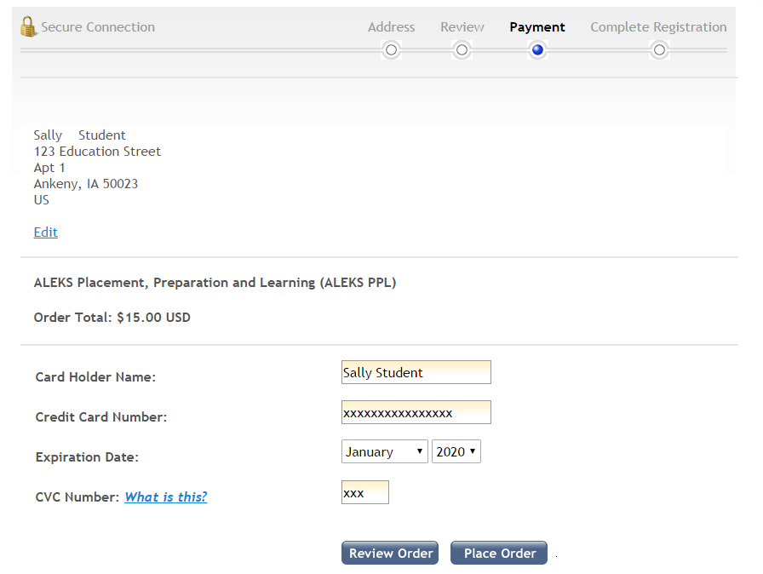

- IMPORTANT: Click on Complete Registration to complete your purchase.

- Click on CONTINUE SIGN UP to register your access code.

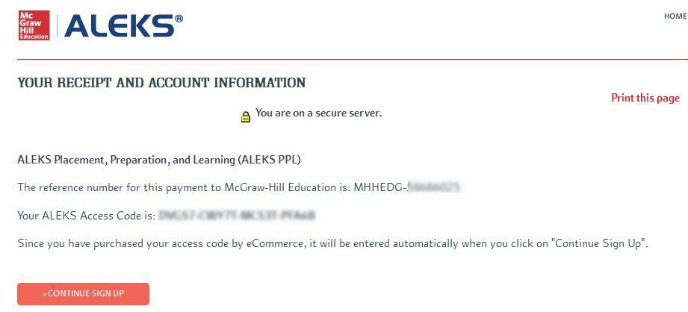

- Click CONTINUE TO YOUR ALEKS CLASS. You will now be brought to your student account.
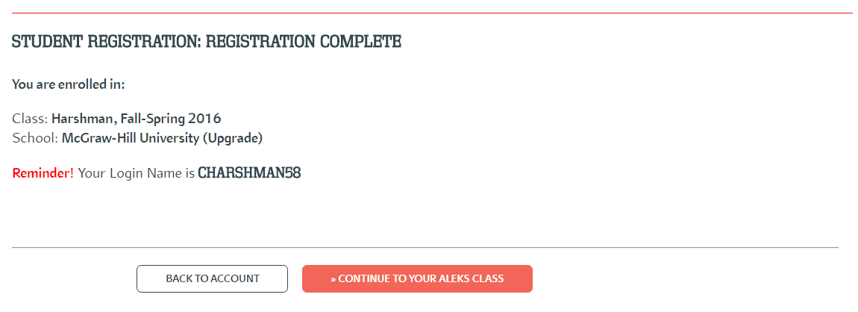

Technical Support
Where can I get help with ALEKS?
http://www.aleks.com/faqs/technical
http://support.aleks.com/assess_placement

